**Paper Report**

On

**Water Filtration System using 3D Printing**

Submitted to

AMITY SCHOOL OF ENGINEERING AND TECHNOLOGY

Noida, Uttar Pradesh



In Partial fulfillment of the requirements for the award of degree

Of

Bachelors in Technology

In

Information Technology

By

**Janmejay Chandrawat**

**A2305318058**

Under the guidance of

**Mr. Pritish Shubham**

CERTIFICATE

On the Basis of the Declaration Submitted by Janmejay Chandrawat (Enrollment No.: A2305318058 ) student of B. Tech Information Technology, I hereby certify the report entitled “Water Filtration System using 3D Printing”, which is submitted to Amity Innovation and Design Centre, Amity School of Engineering and Technology, Amity University, Noida, Uttar Pradesh in partial fulfillment of requirements for the award of the degree of Bachelor of Technology in Information Technology is an original contribution to existing knowledge and faithful record of work carried out by them under my guidance and supervision. To the best of my knowledge this work has not been submitted in part or full for any degree or diploma to this university or elsewhere.

(Signature of the Guide)

Date: __ /__ /____

Mr. Pritish Gautam (Faculty Guide) ASET,Noida.

ACKNOWLEDGEMENT

We would like to thank everyone who helped us to accomplish our report. We sincerely thank all our respected teachers, who have helped us with their valuable and appropriate suggestions and supported us throughout the development of our report.

We are highly thankful to our project guide Mr. Pritish Gautam for providing her help and assistance at every stage of the report.

(Signature of the Student)

Date: __ /__ /____

DECLARATION

It is hereby declare that the project titled as “ Water Filtration System using 3D Printing” for the final project of Introduction to 3D Printing course is submitted by **“JAY”** team of B.Tech (**IT**) to Amity Innovation and Design Centre, Amity University Uttar Pradesh, Noida, is an authentic record of our own work.

The matter presented in the report has not been submitted by us for any other program of this or any other institute.

Janmejay Chandrawat

A2305318058

B. Tech (IT)

2018-2022

Date:

**Index**

|  |  |  |
| --- | --- | --- |
| **S.NO** | **TABLES OF CONTENT** | **PAGE NO.** |
| 1. | Abstract |  |
| 2. | Introduction |  |
| 3. | Overview of Fusion 360 |  |
| 4. | Overview of Ultimate Cura |  |
| 5. | Water Filtration Process |  |
| 6. | How Clean Water is Important for environment? |  |
| 7. | Materials |  |
| 8. | Design Methodology |  |
| 9. | Functioning of 3D printed Water Filter |  |
| 10. | Results |  |
| 11. | Conclusion |  |
| 12. | References |  |

**WATER FILTRATION SYSTEM USING 3D PRINTING**

**ABSTRACT**

Additive Manufacturing which is popularly known as 3D printing is driving advancement in numerous ventures and scholastic exploration including the water asset area. The ability of 3D printing to create complex items in a quick and practical way makes it profoundly attractive over traditional assembling measures.

Ongoing years have seen a quick expansion in research utilizing 3D printing for layer detachment, desalination and water cleansing applications, possibly changing this field. This survey centers around late progressions in 3D-printed materials and strategies for water-related applications remembering improvements for module spacers, novel filtration and desalination films, adsorbents, water remediation, sun oriented steam age materials, catalysis, and so forth.

The rise of new 3D printers with higher printing goals, better productivity, quicker speed, and more extensive material materialism has earned more revenue and can possibly reshape innovative work in this field. The promising potential, difficulties and future possibilities of 3D printing, added substance assembling, and materials for water asset and treatment-related applications are completely talked about in this survey. With the use of various improvement apparatuses and added substance fabricating virtual products, we effectively made our Water Filtration model.

The fundamental model of the channel is the chamber which has been shelled and the base surface has a few openings from which the water may enter or spill out contingent upon the direction of the channel and the position.

Consequently because of its compactness just as moderateness it tends to be utilized by most of the populace in an assortment of purposes and in any structure. In our examination we have demonstrated the utilization of debased water.

**INTRODUCTION**

3D printing is considered as a method of making the three-dimensional objects that are solid in nature with the use of different development tools. The process that is used to accomplish the goal of making the 3D printed objects is the Additive processes. The process basically deals with the creation of establishment of consecutive layering of the material of our choice and continuing the process unless the proper formation of the object is made.

The basic purpose of the 3D printing process is to manufacture the concept, different types of prototypes that are demanded and after working on the whole process of 3D processes we get the desired end product. When we look forward to the working of 3D printing, it involves different varieties of 3D printing technologies to create different parts of our design as per the prototype we have developed. It is very important to choose a suitable 3D printing technology that is favorable for the type of solid object we are printing. When it comes to the selection process the possibilities are endless but it depends on our skills that how we choose the best one, and once the best process is finalized the process of creating the desired object becomes very efficient.

Our research work basically revolves around a model that we made with the help of 3D printing processes and its development tools. The model that we have made is a water filtration process that basically purifies the water which consists of macro impurities.

As it is well known that pure water is very important for our health and overall well-being. The main motive and innovation of our 3D printed solid model is its flexibility and scalability.

In our research we have tried to make the cap of the bottle universal so that it can be used in maximum types of way and thus its usability increases. We have used the two basic development tools of 3D printing that includes Fusion 360 and Ultimaker Cura, the methods and the materials we have used will be discussed in this paper along with the methodology of Designing the bottle which will consist of the filtration equipment.

**FUSION 360**

Autodesk Fusion 360 is a CAD i.e Computer Aided Design tool which is made by Autodesk, a industry giant in Design and Modelling Software. Autodesk has also made some industry standard software such as AutoCAD and Inventor while Fusion360 is more oriented towards 3D printing applications

Fusion 360 is an excellent tool for modeling 2D and 3D objects for very precise dimensions, but there are other features such as the ability to animate designs, to render objects in real time, simulation of different loads, and most important preparing models for 3D printing. It is used by many businesses, small and large alike, they use this platform for the design and making prototypes of their products and ideas.

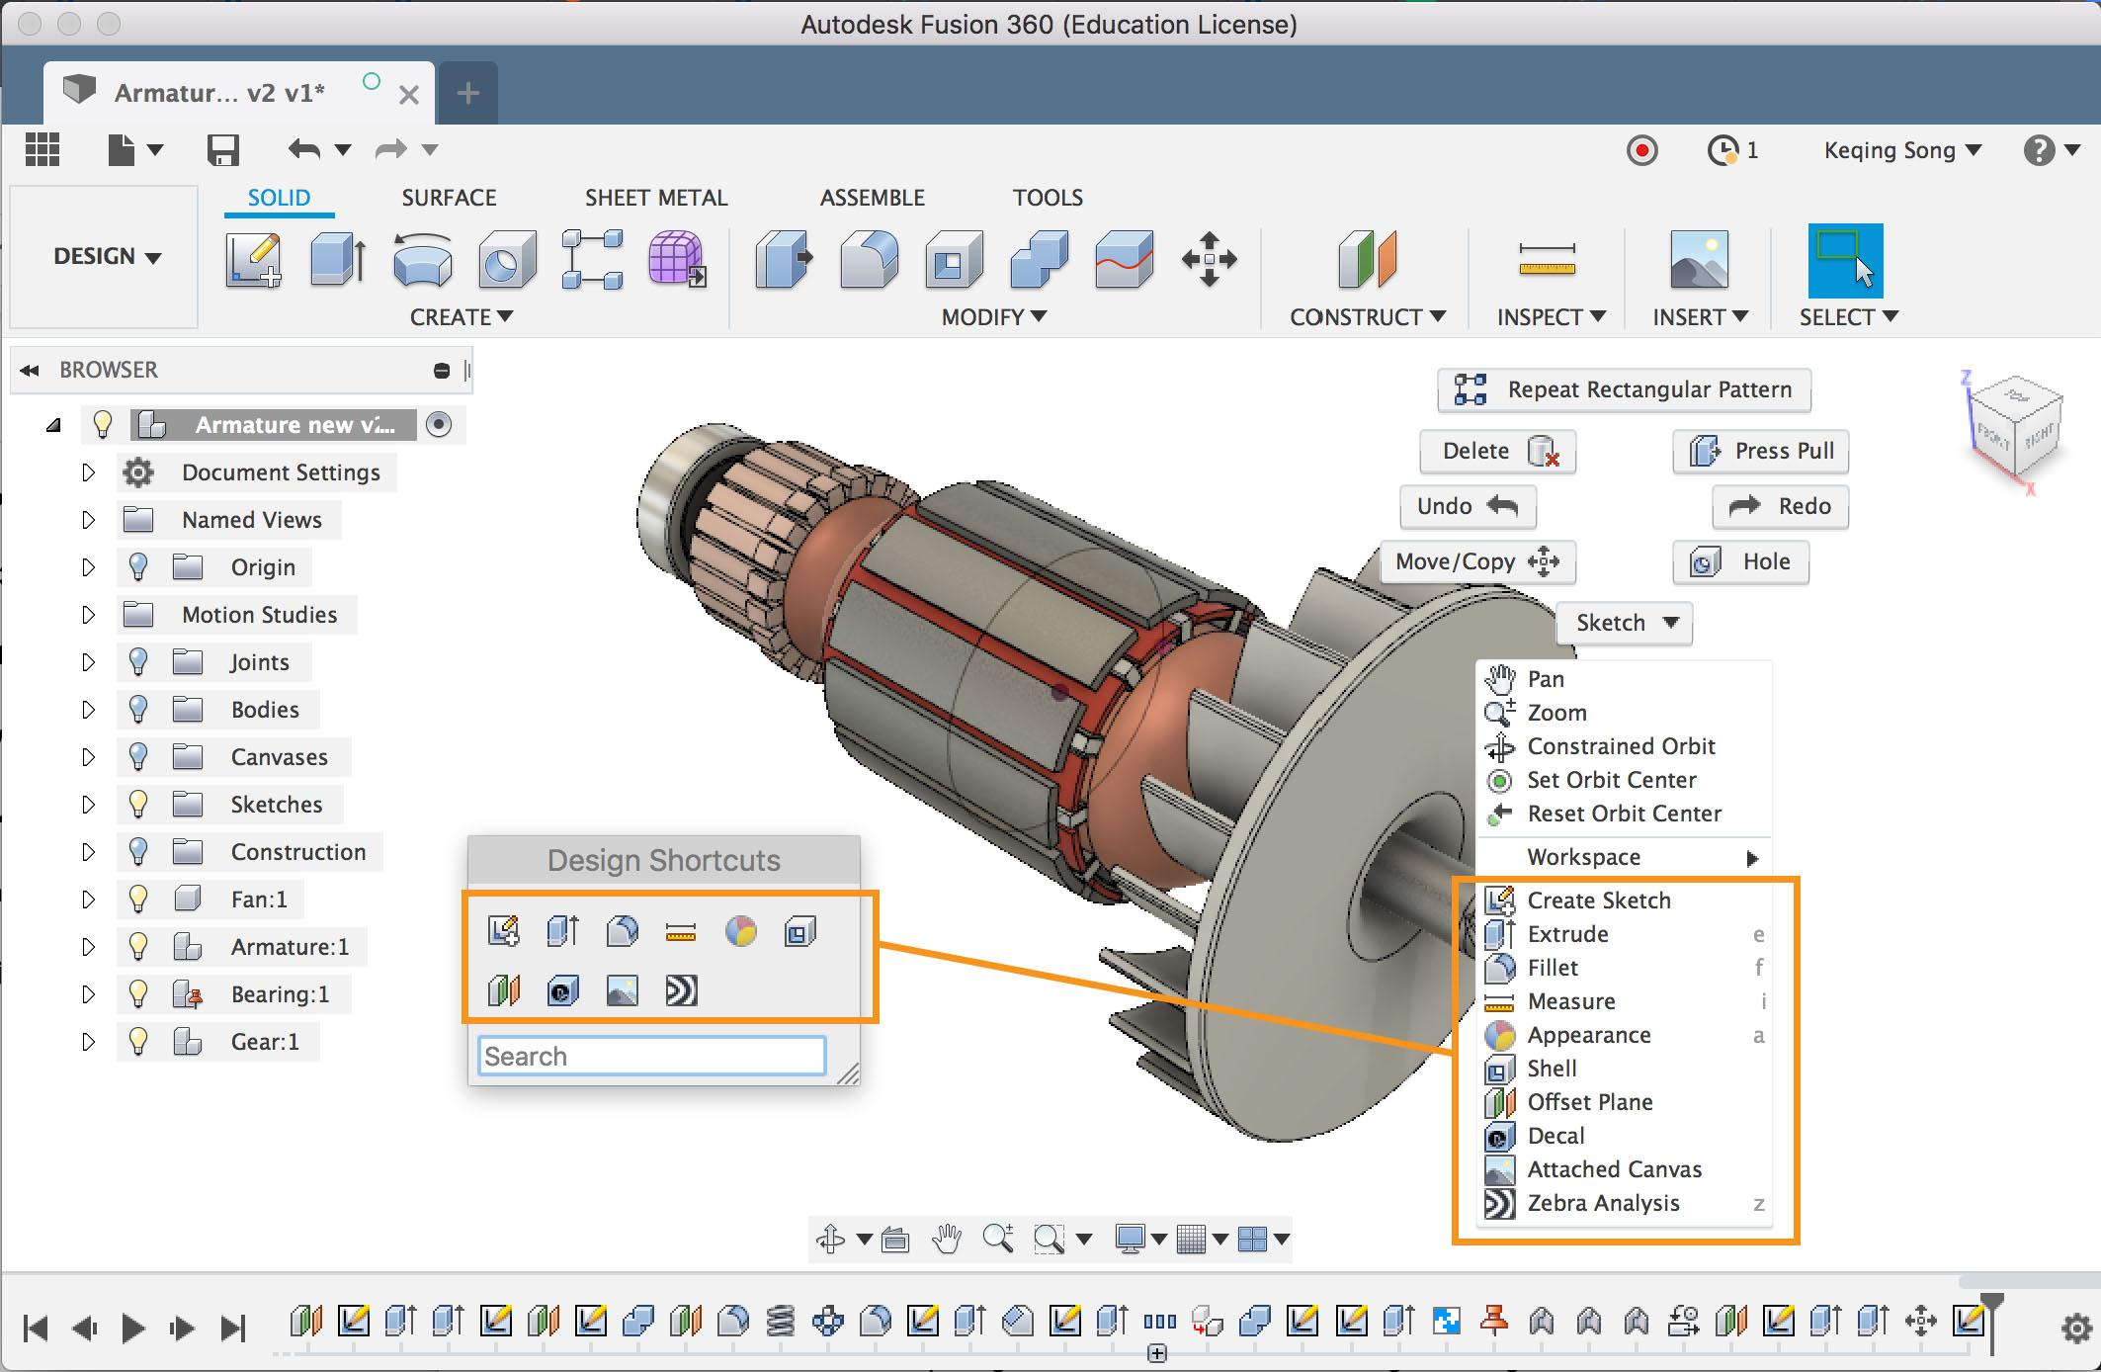

Figure - Example of Rendered Model

**ULTIMAKER CURA**

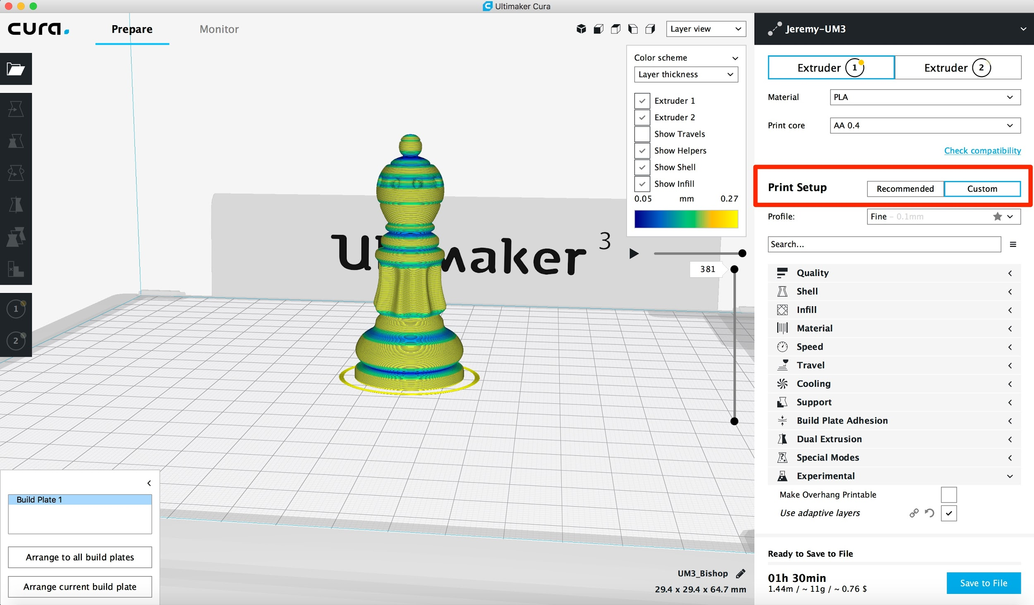Cura is a software which is used for slicing 3D models into layers. It was developed by David Braam in 2014 specifically for this purpose only, it was later acquired by Ultimaker. It is an open-source software, it is probably the widest used software in the 3D Printing and Manufacturing Market. The previous year, Cura had approximately 600,000 users and is estimated to have been used for more than 8 million printing jobs every month.

Figure - Example of a Bishop sliced in Cura

The benefits of Cura are:-

* Ease of Use
* Support for different file formats such as STL, OBJ, X3D and 3MF
* Compatibility with various 3D printers.
* Compatible with most common Operating System - Windows, MAC and Linux

**WATER FILTRATION PROCESS**

Some filtration processes are more efficient at removing particles and contaminants than others. Here's a quick overview of each type of water filtering method that can be used in our project.

1. ***Activated Carbon:*** By chemically reacting to the water which is placed into the device, carbon prevents pollutants. Some only extract chlorine efficiently whereas others eliminate more harmful chemicals, like lead or mercury .Carbon filters are generally sold in markets in the form of grains or block.

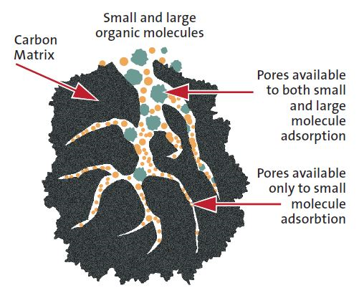

Figure: Working of Activated Carbon

1. ***Distillation:*** This process evaporates water by bringing it to extremely high temperatures. The vapour is then distilled away into healthy drinking liquid water. Distillation extracts minerals, microorganisms, and chemicals which have an increasing boiling point.

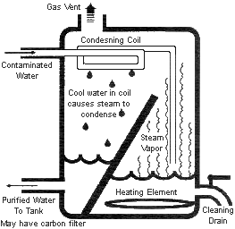

Figure: Distillation of Water

1. ***Ion Exchange:*** Ion exchange uses a resin to substitute toxic ions with less harmful ones. As it has the capacity to substitute magnesium and calcium with sodium, ion exchange is also utilized for softening of water.

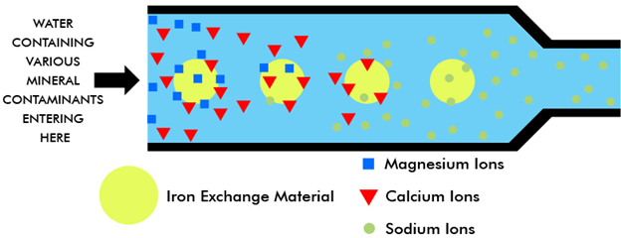

Figure: Process of Ion Exchange

1. ***Reverse Osmosis:*** Reverse osmosis involves pushing water via a semipermeable membrane. Since this procedure may cause blockage to molecules which are bigger than water, it is not possible to eliminate pollutants with larger molecules, like chlorine.

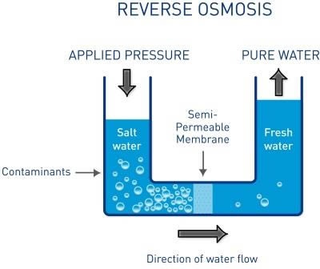

Figure: Process of Reverse Osmosis

1. ***Carbon Block:*** Block-shaped filters that are made of crushed carbon particles are carbon block filters.. The pace at which water flows through these filters directly affects their efficiency level.

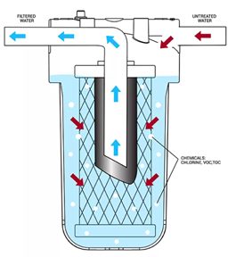

Figure: Carbon Block Filtration

1. ***Granulated Carbon:*** These filters use tiny particles of carbon to purify water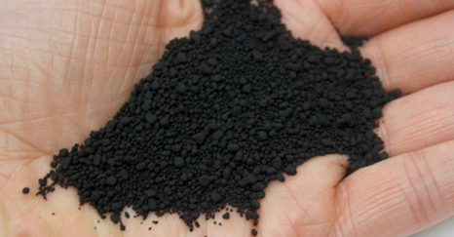

Figure: Granulated Carbon Filtration

**HOW CLEAN WATER IS IMPORTANT FOR THE ENVIRONMENT?**

Science in its various famous studies has demonstrated that a normal being can live without food approx 2-3 weeks but when it comes to water a normal person can die if he/she does not get water for 3-4 days. This itself explains how important water is in our existence on earth. When it comes to the importance of clean water, it plays a very vital role in the proper functioning of the environmental cycles as well as the working of the human body.

Some of the points that states very clearly that why everyone needs clean drinking Water:

1. ***PROVIDE NOURISHMENT***-As from our early life, we have heard that Water is said to be another name for life. So it's a fact that water has many nutrients and humans need them to uplift the organ health and allow the blood to maintain the proper flow of blood and transport of various nutrition.
2. ***THE PREVENTION OF DISEASES***- If we do not consume clear and pure water in our daily life then it can lead to various fatal medical conditions that includes typhoid hepatitis A as well as Cholera. Contaminated water according to the recent research has led to many chronic diseases that have increased the mortality rate in the recent decades. Clean water is not just essential for being safe from diseases but it also helps us to maintain good health.
3. ***HELPING IN GETTING RID OF TOXINS***- Body creates and generates various different types of toxins on the daily basis of food that we consume and our daily regular habits. Tense in order to flush it out from our body.
4. ***FOR AGRICULTURE AND FOOD PRODUCTION***- The basic requirement for the food to grow is water that is provided through irrigation in the fields, if the water is contaminated then there will be a negative impact on the crops and the agricultural fields that can lead to major hazards in the coming times. Hence it is important that clear water is irrigated in the crop fields and yards.
5. ***IMPROVED SANITATION FACILITIES***- Clean water is not just required for drinking but it is also required for the purpose of sanitation.  In some cases it was seen that the cooking and the cleaning was not done with proper clean water hence the diseases were spreading and degradation of good health was happening.

Hence with the use of our 3D printed model  we are trying to make a portable as well as affordable water filtration bottle that can be used by the majority of people in any form they choose to use it.

**MATERIALS**

**MATERIALS THAT CAN BE USED IN OUR PROJECT**.

Water filter material could include one or more carbon combinations such as activated carbon, like simple mesoporous wood activated carbon, that may be a porous carbon block or a tube or carbon powder or particles fabricated with a plastic binding material. A coffee paper, an ion exchange material like resin beads, flat filtration membranes, fibrous filtration structures, etc., zeolite particles or coatings that are silver loaded, polyethylene, or charge-modified melt-blown or micro-fiber glass webs, alumina, diatomaceous earth, etc. could also be utilized in the project. A water filter material consisting of activated carbon particles may allow the water filter to treat approximately 100% of all untreated drinking water entering the water. Therefore, for consumption, about all (100 percent) of the untreated drinking water that reaches the water filter system is made available. The design of the filter is made such that the filter may prevent clogging of the filter material after the process.

**WHY IS CHARCOAL THE BEST WATER FILTER?**

1. ***Minerals remain***: Drinking water is not only made from oxygen and hydrogen, there consists of a lot of different elements that contribute to the water composition, in addition to unpleasant chemicals and contaminants.
2. ***It makes it healthier:*** safer. Activated charcoal can put vital minerals like magnesium, calcium and iron back into the water in order to improve the quality of the water.
3. ***It enhances the taste:*** It enhances the taste of water and prevents chlorine and ugly odors. Chlorine is necessary to ensure that our water supply is clear of bacteria and viruses; we do not need to consume chlorine / a disinfectant, nevertheless
4. ***It is cheap:*** For your home, several water filters can be a costly, but required, investment. But at the other end, charcoal filters are relatively cheap to make, and these savings are handed down to the user.
5. ***It is easy to maintain:*** Although the charcoal is already used, the filters need to be checked, the new components are cheap and easy to assemble and attach. It is essential to alter your carbon filter approximately each six months.

**FUNCTIONING OF 3D PRINTED WATER FILTER**

The main model of the filter is the cylinder which has been shelled and the bottom surface has some holes from which the water may enter or pour out depending on the orientation of the filter and the position. Inside the cylinder, there is another cylindrical disk which acts as a sieve due to very tiny holes which only permit some amount of water to go through which will then get filtered through the Water Filter Material that is being put inside the cylinder. The cylinder has 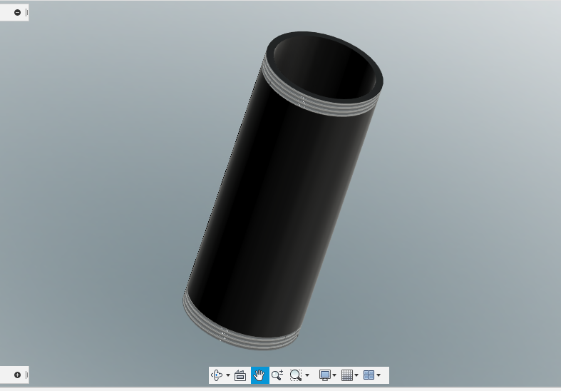

Figure - Cylinder

threads on either side to incorporate the universal nature of this filter and so that the caps can be attached to the filter simply by tightening the cap.

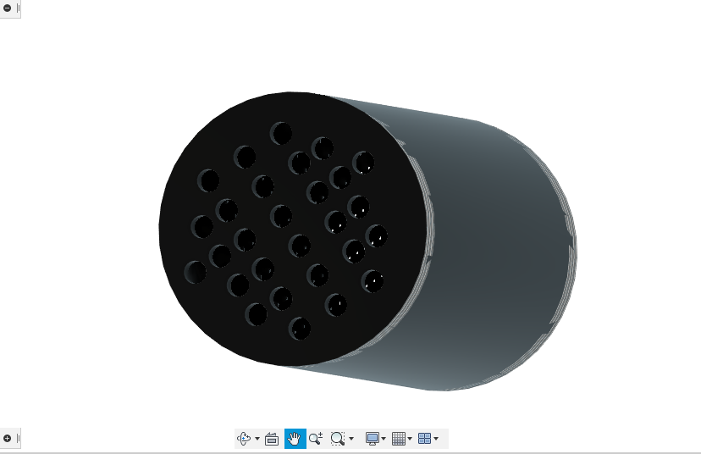

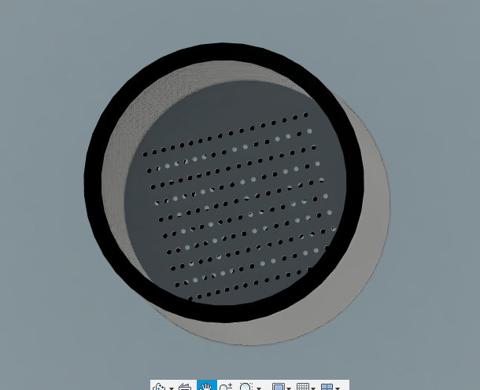

Figure - Inside View of the Cylinder, Bottom Side of the Cylinder

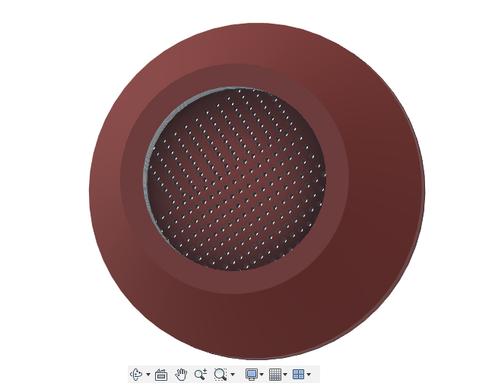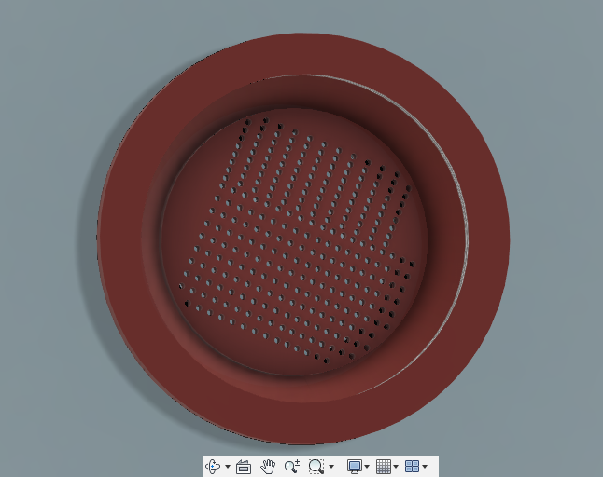The caps have been designed to attach to the cylinder as well as to the apparatus for which the cap has been made. The caps also have cylinder discs with small holes which act as a sieve same as in the main cylinder. The caps which we have made as examples are of a pipe and plastic water bottle. The water bottle cap will attach directly to the cap and then to the cylinder.

Figure - Top / Bottom View of the Cap

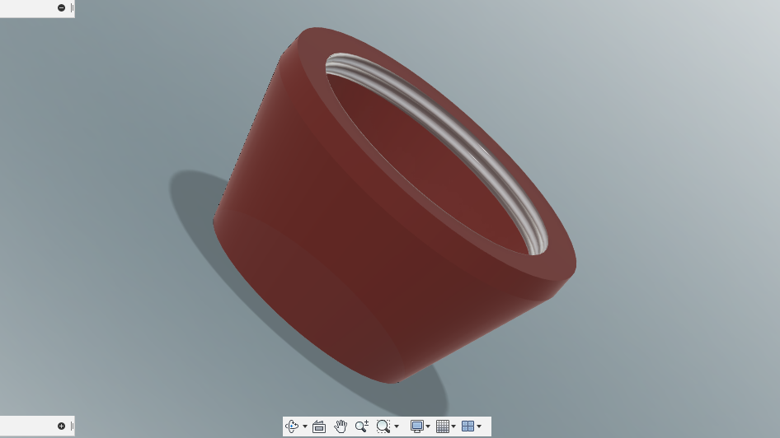The Cap also has threads on both sides so that it can be attached to the bottle as well as the container.

Figure - Plastic Water Bottle Cap for filter

The pipe cap has threads as well a smaller hole so that the rubber can fit perfectly in the cap with no gap.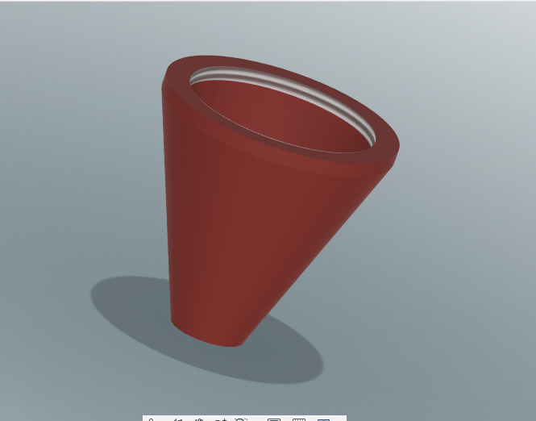

Figure - Pipe Cap

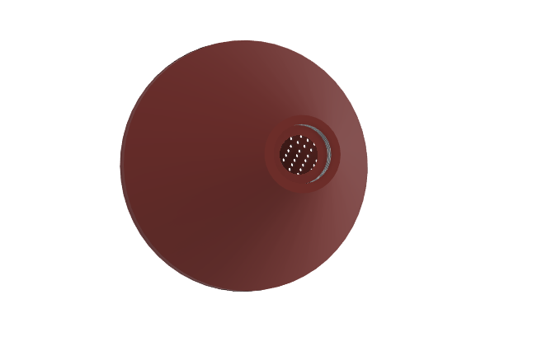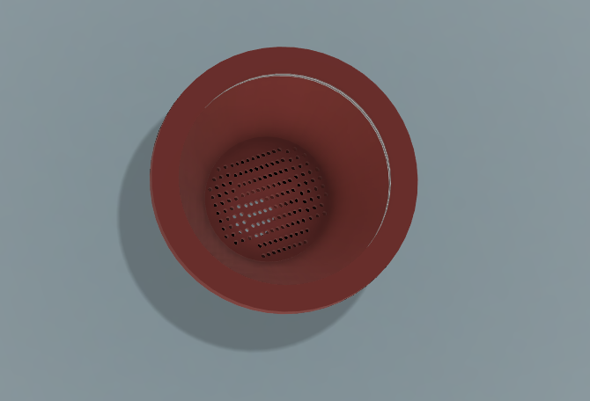Figure - Top/ Bottom View of Pipe Cap

**RESULTS**

With the usage of different development tools and additive manufacturing software, we successfully made our Water Filtration model. The main model of the filter is the cylinder which has been shelled and the bottom surface has some holes from which the water may enter or pour out depending on the orientation of the filter and the position. Thus due to its portability as well as affordability it can be used by the majority of the population in a variety of purposes and in any form. In our research we have shown how the consumption of contaminated water.

As of late, AM (3D printing) has given astounding headways in film module plan, composite layer creation, advancement of oil-water partition and wastewater treatment materials, and so forth regardless of the impediments on cost, speed, printing goal and material determination. Expanding number of examination bunches are using 3D printing for planning convoluted structures effortlessly of prototyping and tests for different water-related applications.

**CONCLUSION**

After working on various aspects of 3D printing processes as well as building up the water filtration technology for the betterment of the water quality. From this we observed that there is scope for considerable upgradation in the environmental impacts of 3D printing basically focusing on the essentiality and importance of clean water and eradication of contaminated water.

In this way we can also conclude that, because of its movability just as reasonableness it very well may be utilized by most of the populace in an assortment of purposes and in any structure. In our examination we have demonstrated the utilization of defiled water.

The beginning stage can be a proactive thought of natural components from the start of creation/item plan. More noteworthy exploration looking at financial and natural effects of various printing approaches and featuring appropriateness of cycles to explicit plan necessities could encourage a move toward lower sway 3D printing and amplify the capability of 3D printing to free originators from the limits of customary creation.

**REFERENCES**

1. Vinod G. Gokhare, Dr. D. N. Raut and Dr. D. K. Shinde (2017). “A Review on 3D Aspects and Various Processes used in the 3D-printing.” *International Journal of Engineering Research and Technology(IJERT)*, 2278-0181.
2. Samer Mukhaimar, Saed Makhool and Qais Samara(2014). “3D Printing Technology”. *Birzeit University,* 272789911.
3. Leonard D Tijing, John Ryan Cortez Dizon, Idris Ibrahim and Arman Ray Nisay(2019). “3D printing for membrane separation, desalination and water treatment”.*Journal of Applied Materials Today, DOI:* [*10.1016/j.apmt.2019.100486*](https://www.researchgate.net/deref/http%3A%2F%2Fdx.doi.org%2F10.1016%2Fj.apmt.2019.100486)
4. Bridget O’ Neal,(2020) “International Study Develops 3D Printed Water Filter for Affordable Arsenic Removal”, *Blog on 3D PRINT.*
5. Zhichao Liu, Qiuhong Jiang, Yang Zhang, Tao li and Hong-Chao Zhang, “SUSTAINABILITY OF 3D PRINTING: A CRITICAL REVIEW AND RECOMMENDATIONS”, *Proceedings of the ASME 2016 International Manufacturing Science and Engineering Conference,* MSEC 2016-8618.
6. Mohammad Reza Khosravani and Tamara Reinicke(2020). “On the environmental impacts of 3D printing technology”, *Journal of Applied Materials Today.* DOI: 10.1016/j.apmt.2020.100689